**RUSA Allocations Board**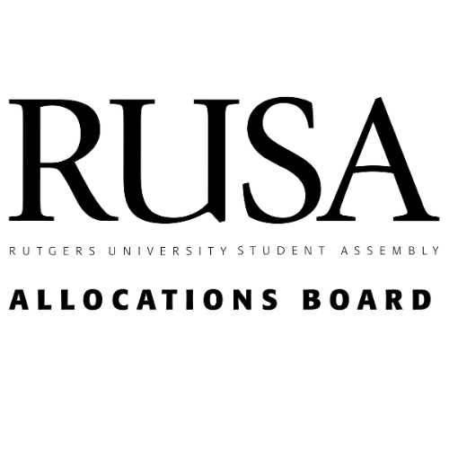

**Cap Sheet Report Fall 2021**

**Outline:**

**I. Introduction**

* Background
* Goals
* Explanation and Defense of Cap-based System

**III. Cap Breakdown**

* Model Concept
* Model Breakdown
* Standalone Programs
* Series Program
* Trip
* Series Trip
* Conference/Team Competition
* Organizational Maintenance

**IV. Summary and Future of Caps**

* Model Goals
* Communication
* Auditing

**Executive Summary**

Highlights of Report:

1. Given the Board’s expectation of student organizations to gradually increase event activity through the semester, we used the itemized caps from the previous semester. No major changes were made to the cap sheet or the process due to no changes being necessary at this moment.
2. For the Spring 2022 semester, the event types being funded in a virtual environment are Standalone Program, Series Program, Organizational Maintenance, Standalone Trips, Series Trips, and Publications. However, there may be exceptions, so we have performed due diligence on such clubs in the Spring 2022 Budget Weekend and also encourage respective applicants to come to semesterly Appeals Meetings.
3. Dynamic Caps have been re-calculated and re-applied to fundable categories. The Dynamic Caps model uses historical correlations between attendance, amount requested, and amount funded. The data pulls from from Spring 2022 request values and the new Dynamic Caps models (for the correlations and historial amount funded)

**I. Introduction**

As per the RAPTA bill, passed Fall 2019, the RUSA Allocations Board aims to make its operations and process as transparent as possible. This is to ensure organizations on campus that decisions regarding their funding undergo rigorous analysis, auditing, and evaluation. The Board focuses on fairly and effectively allocating student fees to all university organizations under the RUSA jurisdiction. Recent efforts include systemizing the funding analysis, digitizing club request data, and improving the auditing process. Winter 2020 the Board designed a new, more intuitive funding model with the goal to utilize historic data, create more flexibility to handle unforeseen circumstances like COVID 19 and make the model easy to understand.

**II. Dynamic Caps Model**

This report itemizes the procedures and considerations of the RUSA Allocation Dynamic Cap model. The model aims to quantitatively determine organization allocation to ensure equity, efficiency, and efficacy.

1. **Model Concept**

The model is broken into two parts: calculating group size category cut offs and unit rate prices per person. The model makes use of club funding data collected over time. The board collected three data points: attendance, request, and amount funded. This yielded a unique linear model for each funding category.

Group size category cut off calculations are done by splitting the non-outlier attendance data into 5 segments. Each segment defines a size category (XS, S, M, L, XL). Unit rate per person is calculated by dividing the total amount asked by total attendance. A linear regression is performed to generalize. Finally, the two parts are brought together by finding the appropriate unit rate for the category sizes (if XS is up to 50 attendees, then we find what the unit cost for 50 attendees is) multiply unit rate with max of category size (if we found $2/person when 50 attendees, then max allocation for 50 people, XS group, is $100).

1. **Model Breakdown (Technical)**

**R ~** request amount | **n ~** number of students attending the event

1. Linear Regression - to determine unit rate asks
   1. For club event request, get ($ per person) **R / n** - this is our measure of how much clubs are requesting per person
   2. Scatter Plot (x-axis: number of people in the event, y-axis: unit rate ask
      1. Outlier Analysis:
         1. Lower: Quartile 1 - Interquartile range * 1.5
         2. Upper: Quartile 3 + Interquartile range * 1.5
         3. Anything < Lower or > Upper should be excluded when doing the rest of the analysis
      2. Keep outlier data in records but exclude for analysis, visualization, and regression (perform outlier check on x and y-axis data)
   3. Perform linear regression to get trend line formula (save/output formula)
2. Population Distribution - to determine XS, S, M, L, XL category sizes
   1. Perform outlier analysis described above
   2. Evenly split the range of the filtered data into 5 parts
      1. Example:
         1. If after removing outliers lower bound is 10 people and upper bound is 110 people, then split into 5 groups with interval distance of (110-10)/5 = 20
         2. XS max = lower bound + interval = 10 + 20 = 30
         3. S max = XS max + interval = 30 + 20 = 50
         4. M max = 70, L max = 90, XL max = 90+ (upper bound)
3. Putting it together
   1. Input category max size into the regression formula to get max unit rate amount per category:
      1. ex) y=0.05x+.10, input xs max , y = .05*30+.10 = 1.5 + .10 = 1.6
   2. Multiply max unit rate ask with max people in category: XS: 1.6 * 30 = $48. In our hypothetical scenario, a XS group can get $48 max

The biggest advantage of this model comes from the use of the unit rate ask per person. Utilizing this quantity as the centerpiece allows the Allocation Board to quickly and easily factor up or down dynamic caps based on unique circumstances or special observed situations. For example, during the Spring 2021 semester of the Pandemic, the board noted much higher spending in advertising and no spending in room rental. To prepare the caps for Fall 2021, the Board increased the unit rate for advertising and decreased the unit rate for room rental to $0. This ensures all clubs receive the same benefit when circumstances reprioritize spending.

The remainder of this section details all notable changes to the Fall 2021 Caps.

Special Note: The Board prepared allocations for both a virtual and in-person scenario. For each category there is an in-person and virtual cap amount.

1. **Standalone Programs**

Category breakdown (range of attendees in each category):

(XS: 0-74 | S: 75-139 | M: 140-219 | L: 220-329 | XL: 329+)

Virtual Note: In the event Rutgers becomes online, RUSA Allocations has decided not to fund **Room Rental and Equipment** or **Food**.We have instead placed focus on **Advertising, Supplies and Duplications, Contracts, and Other.**

**Room Rental and Equipment**:

Virtual: RUSA Allocations is not funding room rental and equipment during an online Fall 2021 semester.

In-person: Funding caps based on model.

(XS: $ 150 | S: $ 310 | M: $ 490 | L: $ 680 | XL: $ 880)

**Advertising**

Virtual: Shifted unit rate regression up by $0.30 based on trend from past two semesters. Resulted in a $20 upward shift in ad caps.

(XS: 60 | S: 110 | M: 180 | L: 270 | XL: 370)

In-person:

(XS: 40 | S: 90 | M: 160 | L: 250 | XL: 350)

**Food**:

Virtual: RUSA Allocations is not funding food during an online Fall 2021 semester.

In-person:

(XS: 550 | S: 980 | M: 1350 | L: 1630 | XL: 1850)

**Supplies**:

No change in request for supplies between virtual and in-person, so the Board maintained the same caps for both.

Virtual:

(XS: 110 | S: 230 | M: 360 | L: 500 | XL: 660)

In-person:

(XS: 110 | S: 230 | M: 360 | L: 500 | XL: 660)

**Contracts**

The Board continued to use the revamped contracts funding model. The following decisions were implemented as it was shown clubs have been increasingly requesting contracts in an online COVID-19 semester. Historically, RUSA Allocations limited the number of fundable contracts according to the size of the proposed event. RUSA Allocations has instead applied a cap to the total value of all contracts combined.

Virtual:

(XS: 1350 | S: 1970 | M: 3890 | L: 6330 | XL: 8090)

In-Person:

(XS: 1350 | S: 1970 | M: 3890 | L: 6330 | XL: 8090)

1. **Series Programs:**

Virtual: For series programs, the size categories were not as broad as the standalone programs. The costs for series programs tends to be more spread out, so simply multiplying costs by 7 is not feasible. Instead for small series programs, we took half of the extra small standalone program costs and multiplied that by 7. For large series programs, we took half of the small standalone programs costs and multiplied that by 7. Both of these sized events seemed to line up nicely with the attendance projects for most series programs.

In-person: Similar procedure as virtual, but also brought back food and room rental.

1. **Other Trip/Conference/Competition**

Virtual: RUSA Allocations is not funding physical trips during an online Spring 2021 semester. Any online trips have been re-categorized as a Standalone Program.

In-person: Break down below

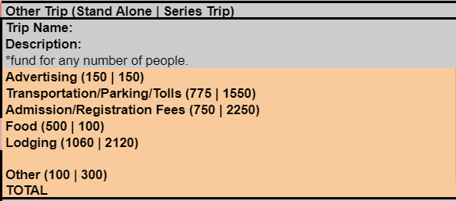

1. **Publications**

Brought back publications for virtual and in-person semester. Same funding for both.

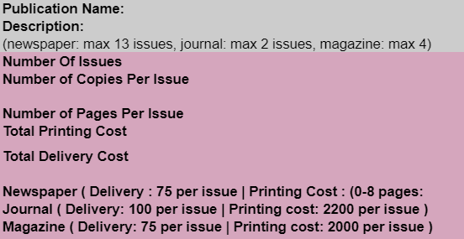

1. **Organizational Maintenance**

Virtual: Only funded office supplies ($200), advertisements ($400), software ($150), and phone charges ($100)

In-person: Usual OM funding if in-person.

1. **Stand Alone Trip/Series - Conference/Competition**

Brought back for in-person only

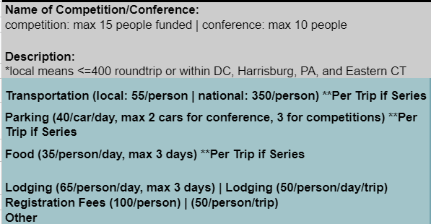

**III**. **Summary and Future of Caps**

This is a foundation for the cap-based models. The current caps represent a much more informed set of numbers compared to previous years. The board will constantly be monitoring the repercussions of this new model. As more information and data becomes available to the Board, this model will become better. The board continues to reevaluate its methods to ensure best practices. Below are a few areas the board aims to address in the coming times:

1. **Model Goals**
   1. Clustering - This process will aggregate similar organizations (i.e. cultural, religious, etc.) and generate a unique model within these clusters.
   2. Market Costs - This term refers to what the mean item category costs at this point in time. These numbers can be pulled from Rutgers-approved vendors which organizations are obligated to work with. The numbers can also be pulled via research of the widespread market averages at this point in time.
   3. Take Backs - With the data available to us, the Board plans to evaluate historically which caps have been successful and which caps have not. The primary metric will be take back amounts. Clubs that see >25% of their semesterly funding taken back will be omitted, while clubs that did not have significant take backs will be integrated into the model. This will ensure that the model does not get inflated by clubs incorrectly demanding very high amounts.
   4. Database - Organize all past club data in a database for easy access and analysis. Building a reliable data storage system will ensure we have high quality data for serving club needs.

1. **Communication**
   1. First, the Allocations Board will try to bridge communication between the Allocations Board, Student Centers, and SABO. By building up a database with the most up-to date information, the board will have a better idea of what students are being charged and will therefore be able to produce more significant data points.
2. **Auditing**
   1. General - The Allocations Board will audit organizations more thoroughly. This will help the Allocations Board understand which organizations effectively spend money, versus which clubs underspend their requests. A robust auditing system is necessary to complement an increasingly transparent system.
   2. Attendance - The board will make concerted efforts to force organizations to track attendance using Campus Labs Event pass. This will give the board a reliable way to track event size. As attendance becomes a more reliable metric, the board can begin to eliminate size categories (i.e. small, extra large), and can generate caps as a direct function of the event size.
   3. Informed Officers - To ensure president and treasurers of clubs requesting money understand the funding guidelines, the Board is ideating a five question exam. The exam would cover questions related to the funding guidelines, and would promote officers to read through the document. Informed officers would make the budgeting process more smooth.

Appendix

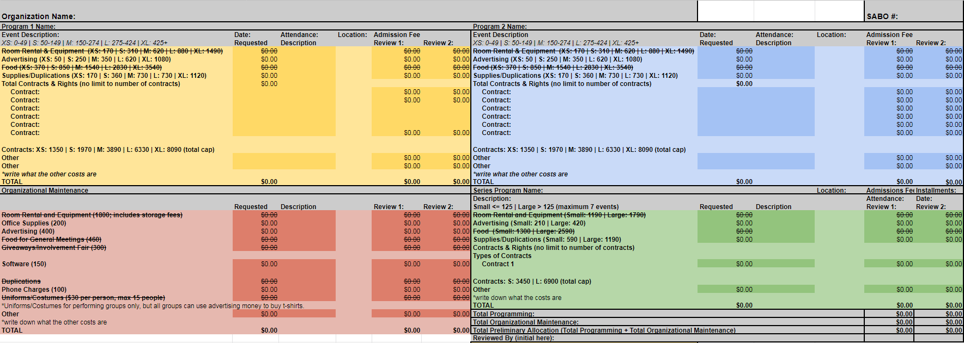

*Figure 1: Caps for Fall 2021 (Virtual)*

|  |
| --- |
| *Figure 2: Caps for Fall 2021 (In-Person)* |